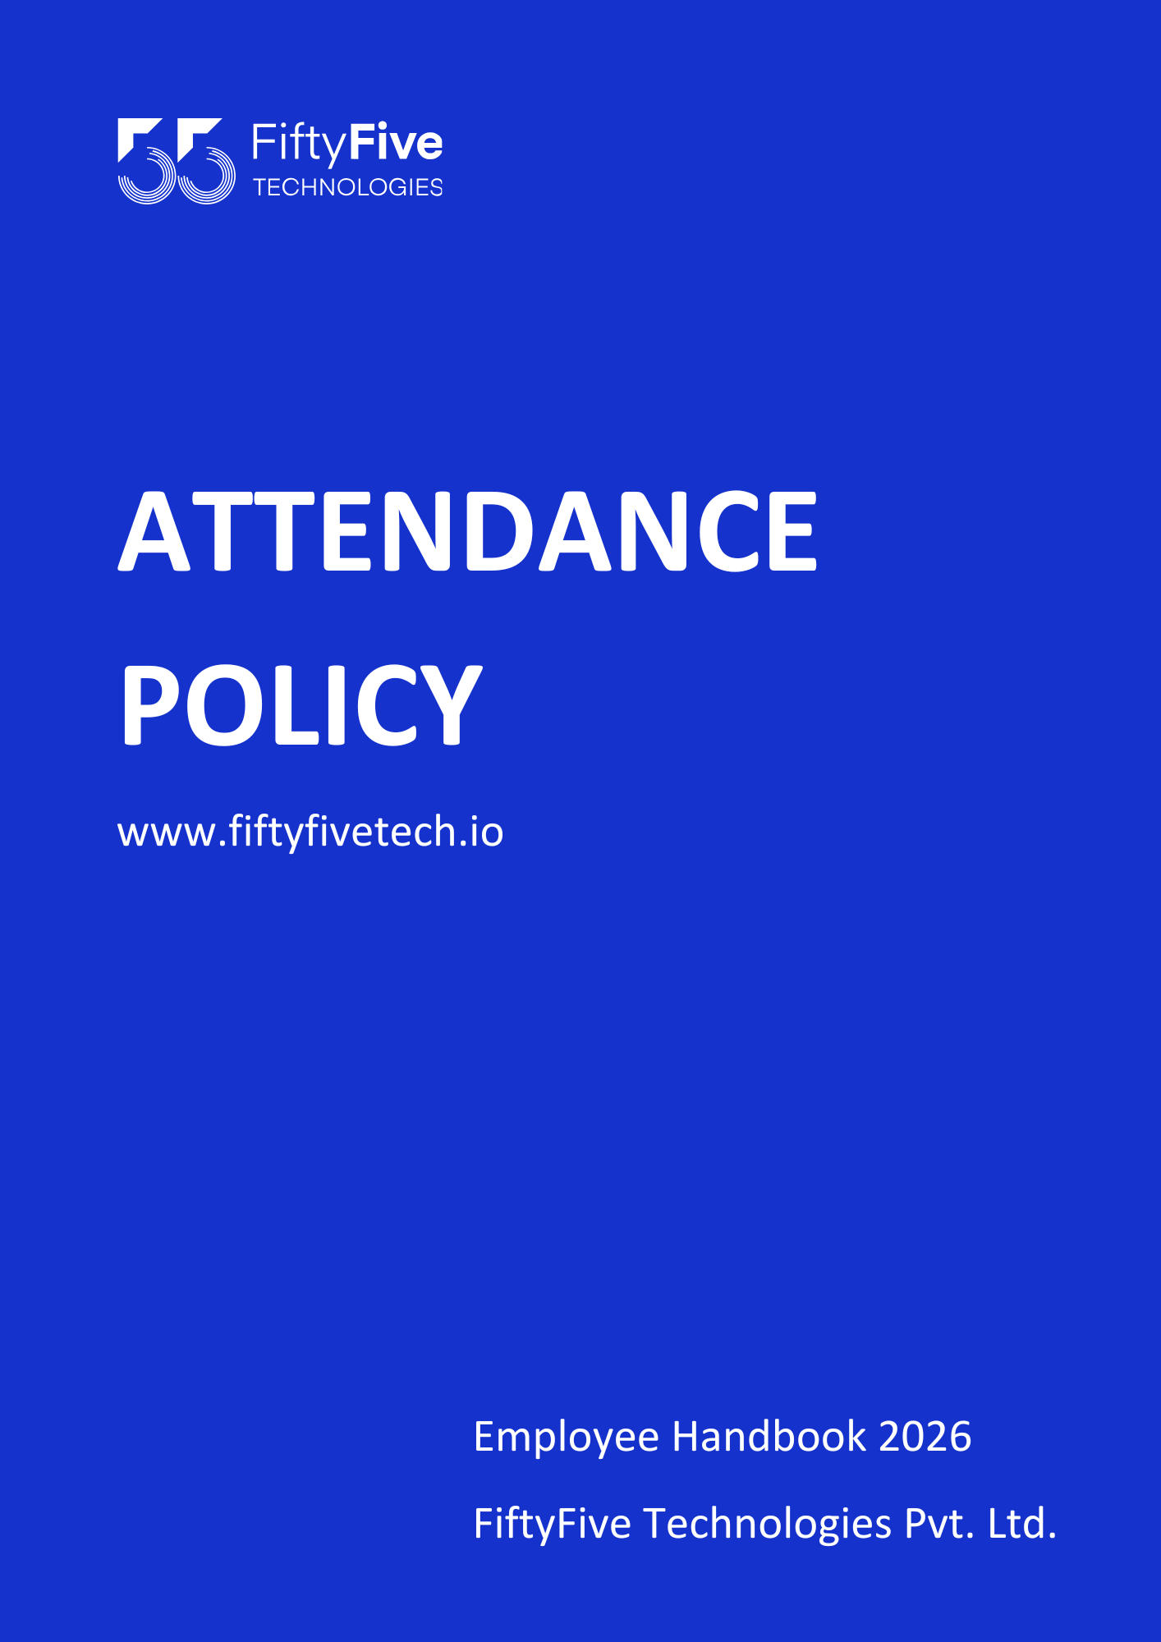

Attendance Policy

Document Release Notice
This FiftyFive Technologies Policy on employee benefits is released for use in FiftyFive Technologies Pvt Limited with effect from 01 January 2026.

This document is subject to FiftyFive Technologies Pvt Limited Procedure and subject to change at any time as per the company policy.

Approved By: Jyothi Sharma (CEO-FiftyFive Technologies Pvt. Limited)
Approved By: Sanchi Saxena (Head HR-FiftyFive Technologies Pvt Limited)

Introduction
This Attendance Policy establishes clear guidelines to ensure disciplined workforce management and uninterrupted business operations at FiftyFive Technologies. All employees are required to report to their designated office location and adhere to prescribed working hours as per their employment terms. The policy defines expectations regarding daily attendance, punctuality, leave, and absence management to maintain operational efficiency, accountability, and workplace consistency. Any deviation from assigned office attendance must be formally approved through defined organizational processes.

Applicability
This policy is applicable to all employees of FiftyFive Technologies across all office locations, including Jaipur, Indore, and Gurgaon, as well as employees working under approved Work from Home arrangements, unless explicitly stated otherwise.

Types of Working Models
The policy defines attendance tracking, working-hour compliance, and reporting mechanisms across the three working models followed by the Company, as listed below.
- Hybrid Work Model
- Permanent / Extended Work from Home
- Work From Office (WFO – 5 Days a Week)
For detailed attendance and penalisation policy applicable to each of the above working models, please refer to the respective provisions section of this policy.

Provisions
Standard Working Hours (All Locations): 8 hours
Standard Shift Timings (All Locations) : 10:00 AM to 7:00 PM
Weekly Working Hours: Minimum of 40 working hours per week, excluding lunch breaks
Break Time : 60 minutes (Lunch/Tea/Short Breaks): Break time allotted for lunch, tea, and short rests; this duration is excluded from total working hours.
Working hours and break time may vary based on project, role, or client requirements. Any deviation from standard working hours must be approved in advance by the Reporting Manager and HR Department.
Employees are expected to maintain punctuality, discipline, and professional conduct to ensure smooth execution of work.

- Hybrid Attendance Policy:
This policy defines attendance tracking, working-hour compliance, and work-from-home procedures for employees following a hybrid work model, ensuring transparency, accountability, and accurate payroll processing.
- Attendance Tracking for Hybrid Employees:
- All hybrid employees must record their attendance through the office biometric system on the days they work from the office.
- Attendance records must reflect a minimum of 8 working hours per day on KEKA.
- It is mandatory for all employees to use Compliance Tool to track working hours, including while working from home (temporary or permanent).
- Employees must ensure Compliance Tool is active during working hours and accurately reflects time spent on work- related tasks.

- Early Office Exit & Continuation of Work Remotely
If an employee needs to leave the office before completing 8 working hours, the following process must be followed:
- Prior approval must be obtained from the Reporting Manager (RM) and HR.
- The employee must clock out through the office biometric system before leaving the premises.
- If the employee continues working after leaving the office, they must remote clock-in on KEKA at the time they resume work.
- All remote clock-in requests are subject to approval by the Reporting Manager and HR.
- Upon completion of work, the employee must remote clock-out on KEKA.
- Total working hours for the day will be calculated based on combined logs from office biometric attendance and approved remote clock-in records.
Failure to follow the above process may result in attendance shortfall and payroll impact.

- Work From Home (Work from Home) Beyond Permitted Limit
Hybrid employees are permitted to work from home for up to 2 days per week by default.
If an employee intends to exceed 2 Work from Home days in a week, the following process must be followed:
- The employee must seek prior approval via email from both the Reporting Manager and HR Department .
- Upon approval, HR will raise and apply the Work from Home request on KEKA on behalf of the employee.
Once the Work from Home request is approved on KEKA, the employee must:
- Log attendance using KEKA as per Work from Home attendance capture scheme for the approved Work from Home days.

- Employee Responsibility & Attendance Accuracy:
It is the employee’s responsibility to ensure:
- Proper clock-in and clock-out on KEKA
- Completion of 8 working hours per day.
In case of missing swipes or attendance discrepancies due to error, the employee must:
- Proper clock-in and clock-out on KEKA and Compliance Tool
- Completion of 8 working hours per day
In case of missing swipes or attendance discrepancies due to error, the employee must:
- HR will not make any attendance corrections. As payroll processing begins on the 25th of each month, employees are requested to review and ensure their attendance is accurate before this date. Be subject to penalties as per the KEKA Attendance Penalization Policy.
- Whenever an employee is away from work, they must update their status accordingly to Compliance Tool.
- If the required working hours are not completed or accurately reflected on Compliance Tool, HR reserves the right to raise an escalation and take necessary action as per company policy.

- Policy Compliance
Failure to adhere to this policy may result in:
- Attendance penalties as per to the penalization policy.
- Payroll impact
- Disciplinary action as per company policies

- Work from Home Infrastructure & Compliance
Employees opting for Work from Home must ensure:
- A proper workstation, such as an isolated room or dedicated office setup.
- Data security and confidentiality at all times.
- In case of any breach of Work from Home requirements or performance concerns, the Company reserves the right to require the employee to report to the office five days a week.

- Policy Review
This policy will be reviewed periodically by HR to ensure alignment with operational needs and system updates on KEKA.

- Permanent / Extended Work From Home (Work from Home) Policy:
  - Eligibility Criteria:
- Employees may be permitted to work from home only if their job duties and role requirements allow and upon prior written approval from the Department Head / Reporting Manager and the HR Department.
- Permanent or extended Work from Home is granted as a special arrangement and is not an entitlement. Approval shall be based on business needs, performance history, and role suitability.
- Any other reasons for Work from Home shall be reviewed on a case-to-case basis by the Reporting Manager in consultation with HR.

  - Attendance & Login Requirement:
- Attendance must be marked only through KEKA web clock-in and clock-out.
- The Asset/IT team will register the employee’s approved IP network on KEKA.
- Employees must ensure that all KEKA logins are done strictly from the registered IP network only.
- It is mandatory for all employees to use Compliance Tool to track working hours, including while working from home (temporary or permanent).
- Employees must ensure Compliance Tool is active during working hours and accurately reflects time spent on work- related tasks.
- Automatic location tracking is enabled on KEKA. Please ensure that if your work location changes at any time, you inform your reporting manager and the HR team in advance.

  - IP Compliance:
- Clock-ins from unregistered or changed IP networks will be:
- Automatically flagged
- Subject to HR/IT verification
- Considered invalid unless prior approval is obtained

  - Change of IP or Location:
- Any permanent or temporary change in internet connection or IP must be:
- Communicated in advance
- Approved by the Asset/IT team and HR
- Updated on KEKA before attendance is marked

  - Employee Responsibility & Attendance Accuracy:
It is the employee’s responsibility to ensure:
- Proper clock-in and clock-out on KEKA and Compliance Tool
- Completion of 8 working hours per day
- In case of missing swipes or attendance discrepancies due to error, the employee must:
- HR will not make any attendance corrections. As payroll processing begins on the 25th of each month, employees are requested to review and ensure their attendance is accurate before this date. Be subject to penalties as per the KEKA Attendance Penalization Policy.
- It is the employee’s responsibility to ensure they are properly available and active on Compliance Tool and Keka during working hours.
- Whenever an employee is away from work, they must update their status accordingly on Compliance Tool.
- If the required working hours are not completed or accurately reflected on Compliance Tool, HR reserves the right to raise an escalation and take necessary action as per company policy.

  - Mandatory Approvals & Compliance
- Employees who choose to work from home without prior approval and without applying in KEKA shall be marked Absent for the day, and applicable disciplinary action may be initiated.
- All Work from Home requests, including permanent or extended arrangements, must be raised and approved in KEKA before commencement.

  - Infrastructure, Data Security & Conduct
- Employees must maintain a dedicated and secure workspace at home (isolated room / proper office setup) to ensure productivity and confidentiality.
- Employees are responsible for ensuring data security, confidentiality, and system safety while working remotely, in line with the Company’s IT and Information Security policies.
- Any breach of security, misuse of company systems, or repeated performance concerns may lead to immediate revocation of Work from Home approval.
- Employees must ensure availability of a stable, high-speed internet connection. Use of mobile hotspots for official work is not permitted.

  - Reporting to Office & Travel Responsibility
- The Company reserves the absolute right to require employees on permanent or extended Work from Home to report to the office at any time, based on business, client, audit, training, or operational requirements.
- In such cases, the employee shall be solely responsible for arranging and bearing all travel, accommodation, and related expenses unless explicitly approved by the company.
- The Company shall not provide any conveyance, travel reimbursement, or relocation assistance for employees working under permanent or extended Work from Home arrangements.

  - Performance, Review & Withdrawal of Work from Home
- Permanent or extended Work from Home arrangements shall be periodically reviewed by Management based on performance, business needs, and compliance with policies.
- The Company reserves the right to modify, suspend, or withdraw permanent or extended Work from Home approval at any time without prior notice.
- Continued eligibility for Work from Home may have an impact on performance evaluation, role expectations, and appraisal outcomes, in line with the Company’s Performance Management Policy.

  - Process for Permanent / Extended Work from Home
Employees must submit a formal request via KEKA, stating:
- Reason for Work from Home
- Duration (temporary / permanent)
Acknowledgement of policy terms The request must be approved by:
- Reporting Manager
- Department Head (if applicable)
- HR Department
Work from Home shall be effective only after written approval is received and documented.

  - Compliance & Action:
Non-compliance with IP or attendance rules may result in:
- Attendance regularization denial
- Payroll impact
- Disciplinary action as per company policy

  - Management Rights
The Company reserves the right to amend, interpret, or withdraw this policy at its discretion to meet business and operational requirements.

Important Points To Note while working from home:
- Communication:
Effective communication is essential for remote work success.
Employees must:
- Employees need to ensure to be available during designated working hours i.e. from 8 working hours with the allocated times reporting to the office i.e. 10:00 AM-7:00 PM.
- It is mandatory to use company-approved communication tools (e.g., email, messaging apps, video conferencing) for work-related discussions.
- Respond promptly to messages from supervisors and colleagues.
- Employees need to install Compliance Tool and function it without a manager or HR interference. Weekly reviews on the same will be conducted with Admin.
- Employees have to adhere to company/project working hours.
- Employees have to participate in weekly connect meetings without fail.
- Employees should update their team status accordingly in case they are away for a few hours to ensure proper communication.

- Equipment:
Employees approved for remote work will be provided with the necessary equipment and resources by the company. The assets allotted to the employees are their full responsibility and the policies followed as mentioned in our employee’s handbook.

- Data Security:
Employees must adhere to company policies regarding data security and confidentiality. This includes:
- Ensuring the security of company-provided devices and data.
- Avoiding the use of public or unsecured Wi-Fi networks for work purposes.
- Reporting any security incidents or breaches immediately to the IT department.
- It is imperative that each employee upholds strict confidentiality and security measures to protect sensitive company data from any unauthorized access, breaches, or mishandling.
- In the event of any data security incident arising from negligence or non-compliance, please be aware that FiftyFive Technologies reserves the right to take strict disciplinary actions, in accordance with our policies and legal obligations.

- Performance Evaluation:
Remote work arrangements will not exempt employees from regular performance evaluations.
Performance will be assessed based on agreed-upon objectives, deliverables, and overall contribution to the team.

- Dual Employment Clause:
In our work-from-home policy, it is explicitly stated that dual employment is not permitted. Employees are expected to dedicate their full working hours to FiftyFive Technologies and are prohibited from engaging in any other form of employment during their contracted hours. This policy is in place to maintain focus, ensure productivity, and prevent any potential conflicts of interest.

- Compliance:
Employees are expected to comply with all local laws and regulations related to remote work by following our terms and conditions mentioned below:
- Ensuring a Proper Setup:
- It is mandatory that employee should have a stable internet connection.
- It is mandatory that employee should have a reliable electricity backup (UPS).
- Employees have to maintain a dedicated workspace at all times.
- Employee needs to ensure to dress appropriately and always keep the camera on during calls (No exceptions are allotted here).
- While planning the sprint they have to inform in advance of their absence if any so that the sprint is planned effectively. Interdependency of the tasks should be planned and managed effectively so that the sprints are delivered on time.

- Travelling While Working from Home:
- Employees need to ensure that the client is not impacted in any way.
- Employees need to make certain that both internal and external deliveries are unaffected.
- Employees have to inform the team and manager transparently and honestly about their travel plans prior in advance.
- Employees should avoid frequent travel and plan leaves for this in advance and inform their manager at least two weeks prior via mail keeping the HRs in CC.
- This privilege should not be misused. The company will review and define exception rules in case any arise.
- The employee must ensure they have reliable network access, as the company will not accept any excuses for not having adequate connectivity.

- Working from Home while sick:
- Employee needs to ensure that the client is not impacted in any way.
- Employees need to make certain that both internal and external deliveries are unaffected.
- Employee have to inform the team transparently and honestly about their condition.
- In case the employee is too sick to contribute, they have to plan and apply for leave as per company policies defined in the Employee’s Handbook.
- No excuses will be entertained in terms of function leaves that are without prior approval i.e., vacation leaves, network issues, or non-availability without intimation.
- While applying for leave no first approval should be taken from the client. It has to be intimated to the manager first and if approved from his side then the request should be intimated or raised to the client.
- This privilege should not be misused. The company will review and define exception rules in case any arise.

  - Client Visits to Office:
When clients visit the office, it is the employee’s responsibility to ensure to come to the office without any excuses to facilitate smooth operations. This will be communicated in advance.

- Employee Exit Process:
In case of any exit of an employee working from home or office. It is the employee’s responsibility to return the assets safely to the IT Admin by following the guidelines of our exit process mentioned in the Employee Handbook.

- Termination of Remote Work Arrangement:
The company reserves the right to terminate or modify remote work arrangements based on operational needs performance, or discipline issues. Employees will receive reasonable notice and an opportunity to discuss any concerns.

3. Work From Office (WFO – 5 Days a Week) Attendance Policy
This policy defines attendance tracking, working-hour compliance, and office presence requirements for employees working from the office five days a week. It ensures workforce discipline, operational continuity, accurate attendance records, and payroll processing.

  - Office Attendance Requirement
- All employees under the Work from Office (WFO) model are required to report to their assigned office location five days a week.
- Employees must adhere to prescribed working hours as communicated by the Company.
- Any deviation from mandatory office attendance must be pre-approved by the Reporting Manager and HR.

  - Attendance Tracking & Working Hours
- All employees must record attendance through the office biometric system on KEKA every working day.
- Attendance records must reflect a minimum of 8 working hours per day on KEKA.
- It is mandatory for all employees to use Time Doctor to track working hours during office work.
- Employees must ensure Time Doctor is active during working hours and accurately reflects time spent on work-related tasks.

  - Early Office Exit on Working Day
If an employee needs to leave the office before completing 8 working hours:
- Prior approval must be obtained from the Reporting Manager and HR.
- The employee must clock out using the KEKA biometric system before leaving.
- Failure to complete required working hours may lead to attendance shortfall and applicable payroll impact.

  - Leave & Absence Reporting
- Any planned absence must be applied through KEKA in advance as per the Leave Policy.
- In case of unplanned absence, employees must inform their Reporting Manager and HR at the earliest.
- Unauthorized absence may result in attendance penalization and disciplinary action.

  - Employee Responsibility & Attendance Accuracy
It is the employee’s responsibility to ensure:
- Proper daily clock-in and clock-out on KEKA.
- Completion of 8 working hours per day.
- Time Doctor is active and correctly reflecting working time.
In case of missing swipes or attendance discrepancies:
- HR will not make attendance corrections.
- As payroll processing begins on the 25th of each month, employees must review and ensure attendance accuracy before this date.
- Discrepancies may lead to penalties as per the KEKA Attendance Penalization Policy.

  - Policy Compliance
Failure to adhere to this policy may result in:
- Attendance penalties
- Payroll impact
- Disciplinary action as per Company policies

  - Workplace Discipline & Conduct
- Employees are expected to maintain professional conduct and discipline during office hours.
- Late arrivals, early departures, or extended breaks beyond permitted limits may lead to attendance shortfall.

  - Policy Review
This policy will be periodically reviewed by HR to ensure alignment with operational and business requirements.

  - Management Rights
The Company reserves the right to amend, interpret, or withdraw this policy at its discretion to meet business and operational needs.

Attendance Penalization Policy
Objective
The objective of this policy is to define attendance-related penalties applicable to employees for non-compliance with the company’s attendance and working hours requirements as recorded on KEKA. This policy ensures consistency, transparency, and timely payroll processing.

Applicability
This policy applies to all employees of the organization, irrespective of role, level, or work arrangement, unless explicitly stated otherwise.

Provisions:
Mandatory Attendance Logging
Every employee is required to mark their daily attendance on the KEKA application. Attendance marking is mandatory for all working days, irrespective of the work arrangement (office, hybrid, or work from home).
Failure to log attendance correctly will result in automatic leave deduction by the system. Any resulting negative leave balance shall be treated as Loss of Pay (LOP).

Attendance Penalization Rules
The following penalties are system-driven and automatically applied by KEKA based on attendance and working hours recorded:

- Late Arrival / Early Checkout / Short Working Hours
Any of the following will attract a penalty:
- Less than 8 continuous working hours
- Late arrival
- Early checkout
Penalty:
- After 2 days, KEKA will deduct 0.5-day (Half-Day) Privilege leave.
- In the absence of PL balance, Loss of Pay (LOP) will apply

- Working Hours Completion
Less than 95% but more than 50% of required daily working hours
- After 2 days, KEKA will deduct 0.5-day (Half-Day) Privilege leave.
- In the absence of PL balance, Loss of Pay (LOP) will apply
Less than 50% of required daily working hours
- After 2 days, KEKA will deduct 1 day Privilege leave.
- In the absence of PL balance, Loss of Pay (LOP) will apply

- Missing Punches
Missing punch-in or punch-out
- After 2 days, KEKA will deduct 1 day Privilege leave.
If PL balance is insufficient
- Loss of Pay (LOP) will be applied

- No Attendance Logged
If no punch-in and punch-out is recorded:
- After 2 days, KEKA will deduct 1 Privilege Leave
- In the absence of PL balance, Loss of Pay (LOP) will apply

Leave Balance Impact
Any negative Privilege Leave balance will automatically result in Loss of Pay. All attendance deductions are system-driven, final, and non-negotiable once applied.

Finality of Payroll Processing
- Payroll processing begins on the 25th of every month
- After this date:
- Attendance penalties are final
- No reversals or modifications will be made by HR
- Payroll will be processed strictly based on KEKA attendance data

Employee Responsibility
Employees are solely responsible for:
- Accurate and timely attendance marking on KEKA
- Completing required working hours
- Regularly monitoring attendance records and leave balances

Enforcement
Non-adherence to this policy may result in:
- Leave deduction
- Loss of Pay (LOP)
- Further disciplinary action as per Company policies

Right to Amend Policies
This Employee Handbook is intended to provide general guidance on Company policies and practices. FiftyFive Technologies reserves the right to amend, modify, suspend, or withdraw any policy, procedure, or benefit described in this handbook at any time, with or without notice, based on business, operational, or legal requirements.



